** JINJA CITY PROFILE**

**VISION**

**“Sustainable and prosperous city with excellence in tourism, commerce and industry”**

# 

# THE MISSION STATEMENT:

*“****To improve the quality of life of all residents through tourism promotion, commercial rejuvenation and a revitalized industrial economy with equitable access and enhanced service delivery in an attractive and sustainable environment.”***

Jinja is arguably Uganda’s heart beat; it is a gem of unrivaled beauty, an asset to Uganda of humongous economic potential and a testament to nature’s benevolence. From playing host to the World’s famous River Nile to anchoring Uganda’s major power dams, Jinja is developing a well planned, serene and tranquil town.

Jinja City is of regional importance as it is considered to be the regional capital of Busoga sub region, Its is growing rapidly as a result of having over 80 industries that employ over 8000 people, Presence of hydro power dams for the supply power for both domestic and commercial use, its location along the Trans African high way, Jinja port, and the railway station that boosts both local and foreign trade. Jinja is also a home to the source of river Nile, the world’s longest river and one of the seven wonders of the world thus boosting tourism. Its also the cultural seat of the Busoga kingdom. Furthermore the presence of private public Patternships that foster development like (madhivan group of co., Bidco, Eskom, Nile breweries etc) are worthy mentioning

**Objectives Of Jinja City.**

1. To promote local economic development.
2. To reduce poverty and improve livelihood status of the community
3. To promote tourism and cultural development.
4. To improve access to quality of Health services and reduce prevalence of HIV/AIDS.
5. To enhance environmental Management and physical planning.
6. To foster education and Human development.
7. To improve Governance and Management.

**Location.**

* Jinja City is located in , Busoga Sub-Region, in the Eastern Region of Uganda Bordered by Kayunga District in the North, Buikwe West, Mayuge South and Jinja District East
* It is approximately 80 kilometres by road, East of Kampala, the capital and largest city of Uganda.
* It sits along the northern shores of Lake Victoria on the source of the River Nile The city sits at an average elevation of 1,204 metres (3,950 ft)

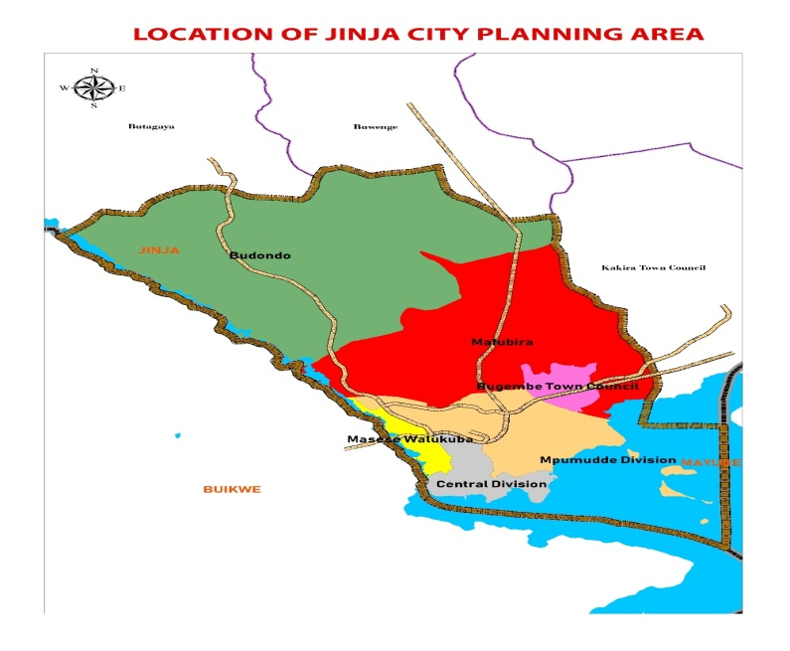

**History Of Jinja City.**

Jinja began as an urban settlement in 1901 by the British as an administrative centre for the Provincial Government Headquarters for Busoga Region.

This was around the time a lake steamer service between Jinja and Port Florence (Kisumu), the port that in 1901 became the terminus of the railway from the coast.

Jinja grew economically with considerable expansion of commercial activities before the town later becoming the focus of modern manufacturing industries and the industrial heart-land for Uganda.

The construction of the Owen Falls Dam in 1947 provided an impetus for these developments and marked a major turning point in the economic development of the town and the country at large.

On the 26th of June, Jinja turned 100 years as a town and cerebrated its century of urban development. In July 2020, Jinja was declared a city.

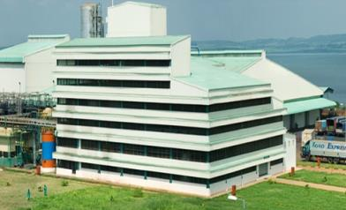 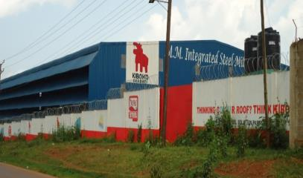

**BIDCO and MMI Steel Roliling industries. Jinja is home to over 80 industries.**

**Topography**

The landscape takes the form of tapering plateau, which sits approximately 1,230 meters above sea level at its highest point. Lake Victoria drains the Municipality and hosting the islands of Samuka , Kisima 1&2 and Lwabitoke which also form part of the town..River Nile roars out of Lake Victoria at Rippon falls and marks the Eastern barder of Jinja.

**Climate**

Jinja City enjoys a pleasant climate with temperature varying between 20C and 30C.It also receives an average rainfall of approximately 112.5 centimeters. The portion of the Nile basin experiences an equatorial type of climate with two dry and two rainy seasons every year. March to May is the main rainy period with April receiving the highest rains. The September to November period constitutes the second rainy season. December to February and June to August are dry periods.

**Soils and vegetation**

The soils range from clay loams, sand loams to Murram in most areas of the City. Vegetation is mainly open Savannah grass which is, in some places mixed with woodland.

**Settlement.**

The City is fairly densely built with high and medium income houses dominating, followed by commercial premises especially in the Central Business District (CBD) and then high-income housing. A series of industrial establishments have also contributed to the city settlements.

**Administrative structure**

The City boundary encloses a total land area of about 215 sq. Kilometers and is compose of composed of 2 Division i.e. Jinja City South (60 sq Km) , 28 of which is covered by water and Jinja City North 155 sq. kilometers

Jinja City is composed of 26 Wards and 141 villages

**Demography**

By 2014 the City had a total population of 247,074. This was night population and estimated at 400,000 during the day. Now as a city the population is estimated at 307,414, persons during the night. The population growth rate is estimated at 3% per annum.

**Jinja city population by 2014**

|  |  |  |  |
| --- | --- | --- | --- |
| **Division** | **Males** | **Females** | **Total** |
| Southern Division | 38,167 | 38,021 | **76,188** |
| Northern Division | 80,000 | 90,886 | **170,886** |
| **Total** | **118,167** | **128,907** | **247,074** |

**Tourist attractions:**

The source of the Nile and the new Nile bridge

Water falls on River Nile like Bujagali falls, Itanda falls,

Historical church at Kamukuzi

Beautiful environment.

Farming practices like Kakira sugar plantation.

Islands like Samuka popular for bird watching.

Water sports like bungee jumping, water rafting on the Nile.

Snake park at the source of the Nile.

Jinja sailing club.

Jinja golf course.

Cultural entertainment.

Floating bar and restaurant.

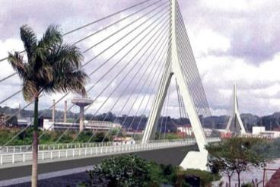 

The New Nile bridge is another tourist Boat cruise on River Nile

site for jinja city

**Water and electricity:**

There is sufficient and reliable water supply by the National Water and Sewerage Corporation from River Nile and lake Victoria serving about 80% of our population. The rest especially in the peri urban areas of Northern Division survive on protected point sources and unprotected ones.

The City is served by hydro electric power from Owen falls dam and power supply is reliable. This power covers about 90% of the City area and serves nearly 80% of our population. It is supplied by UMEME.

**Social Services infrastructure**

In the last 20 years, Jinja city has experienced rapid growth and expansion and is indeed undergoing social economic transformation. However, most of this growth especially in the annexed Northern Division is largely is largely been unplanned especially housing and settlements. This notwithstanding, Physical Planning including costs of plans have been standardized and the regulations are being enforced, the plan approval processes have also been improved.

Progress has been made in solid waste management with major improvements in waste collection, transportation and disposal. Waste collection has been privatized and 6 companies have been contracted, the city authority is only the regulation of the process under the Polluter Pays Principle especially in the southern Division. Efforts to roll this out in the Northern Division are underway. Indeed, the city is visibly clean. There are also on-going efforts to beautify the city including the planting of trees and flowers, landscaping and paving of walkways. Regular sweeping trimming of Road verges by road gangs also keep the help to city clean.

The street lighting of jinja city has been worked on making it one of the most lit cities in the country. Solar lighting has been introduced on the streets like Eng. Zikusooka, Main street, Source of the Nile, bell avenue, Gabula road , Nalufenya Clive Road**,** Masese Landing Site and Kisima Islands and, Ambercourt market, Mpumudde market Walukuba Market**.** Most of the roads in the central business district are lite courtesy of USMID funding and development partners like Eskom Uganda Limited, Madvhanin foundation, Orient Bank, Act Together , Ministry of Tourism and our local revenue.

Under the city road infrastructure, 8 km of roads have been widened and tarmacked, with clearly marked pedestrian walk ways and bicycle lanes on some courtesy of USMID and Uganda Road Fund .Efforts to open roads especially in the Northern Division are underway..

**Education facilities.**

|  |  |  |
| --- | --- | --- |
| 1 | Government Aided Primary Schools | 47 |
| 2 | Government Aided Secondary Schools | 10 |
| 3 | Tertiary Institutions | 7 |
| 4 | University Branches | 3 |

**Health Facilities**

|  |  |  |
| --- | --- | --- |
| 1 | Health Centre II | 7 |
| 2 | Health Centre III | 4 |
| 3 | Health Centre IV | 4 |
| 4 | Hospital (Regional Referral) | 1 |

**Other institutions**

|  |  |  |
| --- | --- | --- |
| **1.** | **Commercial Banks** | **18** |
| **2.** | **Civil service college** | **1** |
| **3.** | **Senior staff and command college** | **1** |

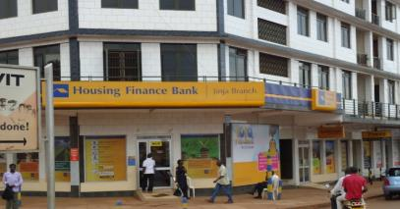 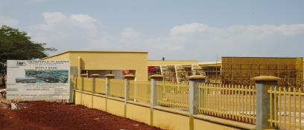

Front view of Housing Finance Bank Uganda Civil Service College

Jinja is home to 18 commercial

Banks.

**Commerce**

Commerce and industry is the dominant component of the economy followed by the service sector, hotel business, Tourism and then agriculture. There is potential for exploiting the idle resources in the sectors of the City.

Commerce is carried out in form of wholesale and Retail trade and is mainly by private practitioners. The City plays a role in this sector through the provision of street lights, construction of roads ensuring the quality of the premises and the licensing of the business units. The various groups in this industry are expected to work in harmony with the City Council to create a favorable environment for smooth commerce. The current level of commerce in the City is fair by the country’s standards, though some improvement is required in the areas of physical places like market places, premises, etc, where commerce is carried out.

Related to commerce is processing and manufacturing sector, popularly known as the industrial sector Jinja City has for long been known as an industrial town with over 80, large scale, medium and small scale industries that employ over 8000 people and contribute handsomely to local and national revenue. Industrial development is attributed to availability of water and power for production and the location on major highways that enable both local and foreign trade. However there is need to upscale the industrial development in the Northern division especially agro processing industries in the areas of Budondo that are predominantly agricultural based..

The potential for industrial development in the City lies in the presence of land, availability of human power, presence of utilities (such as water, power as well as communication), on encouraging central government policy, large demand for industrial products and other elements of the industrial location and operation.

Construction is another key activity going on in the City. A high percentage (about 98%) of this is done by people for their own facilities mainly commercial, residential and industrial premises. The few construction activities of the city authorities are being carried out on contract/tender basis.

Agriculture is practiced on a very small scale where development has not started and on land in the open space such as compounds and road reserves. This agriculture is in the form of crop production and livestock (Zero and free range grazing, poultry and vegetable, farming. It is for both commercial (income generation) and subsistence purposes. This is privately carried out.

**Employment.**

Commerce, trade, industry and public service, tourism , and agriculture are the major sources of employment.

**Potentials.**

Jinja city has several potentials that can be harnessed for its development. They include the following:

1. Presence of diverse fairly skilled, welcoming and accommodative human resources that can be harnessed for development.
2. Availability of well-developed social infrastructure such as Educational Institutions including; top Primary and Secondary schools, Universities, Tertiary institutions, Technical institutions and health facilities.
3. Jinja city location on the shore of lake Victoria and the source of River Nile
4. Jinja city is also a regional hub, with transport connectivity to other towns. It is an emerging metropolitan city servicing other small towns such Kamuli, Buwenge ,Njeru, Iganga, Luuka among others.
5. Jinja city houses the regional administrative centres including the referral hospital, the regional police, Judiciary, land registry and the Bank of Uganda currency centre among others. It therefore offers a one stop centre for many services, creates jobs and incomes.
6. Favorable climate with two rainy seasons a year, the good alluvial soils that can support agricultural production

**Opportunities**

There are various opportunities that can be harnessed to drive economic growth of

jinja city. They include the following:

1. Jinja city is strategically located as along the Trans African High way and and is approximately 80 KM from Kampala which makes conducive for local and foreign trade.
2. Favorable government policy, enabling laws and institutional frameworks for urbanization.
3. Availability of room for urban expansion from peri-urban areas such as Budondo ,Mafubira and Bugembe that have been added together to form the Northern divisions i.e.
4. Compared to other new cities, Jinja has a relatively strong revenue base generated from the manufacturing and processing industries, the hotel business, expanding trade and commerce and the transport industry.
5. Presence of Tourist attractions like the source of Nile, waterfalls, Samuka Islands for bird watching and various hotels.
6. Growing day and resident population that provide market, labour, entrepreneurship and generate incomes directly or indirectly to the city.
7. Motorable road network in good working condition, with connectivity to the hinterland including the neighbouring towns and countires. The road network also offers good interconnectivity within the city and its divisions.
8. Good Governance at all levels of the City that has created a conducive working relationships between the political and technical arms of the city government. The non-state actors including the Private sector, the CSOs, the media, FBOs are all making major contributions to the development of the city. The private sector is making major investments in the city that contribute to employment and a growing revenue base.
9. Security, Peace and Stability. Jinja city has enjoyed a long spell of security, peace and stability that boosted investor confidence and attracted many business ventures in the city.

**Constraints**

1. Weak enforcement of laws, regulations and standards. This is partly due to the low staffing levels, limitations imposed by the current institutional set up/structure with many unfilled offices, attitudinal issues, low facilitation to the enforcement function and the high levels of impunity and corruption among others.
2. Poor Enforcement of physical planning standards is constrained by the unfavorable land tenure system i.e. the phenomenon of “planning for the land you do not own” complicates the council’s ability to attain the Planning Area.
3. The silo approach to work among departments, which makes it hard to harness the inter-departmental linkages and synergies. It is hoped that the programme approach to planning introduced under NDP III will reduce this problem.
4. Poor reporting and information flow limits monitoring progress and identification of challenges, lessons learnt and follow-up actions. This is worsened by poor delegation in some departments.
5. Inadequate revenues to cover the expanded mandate of the new city. The locally generated revenue can only cover 26% of the city budget. There is therefore over-reliance on transfers from the centre whose flows are unpredictable and inconsistent and conditional in nature.
6. Inadequate data on various indicators, sectors, and departments which hinders informed planning.

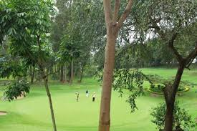 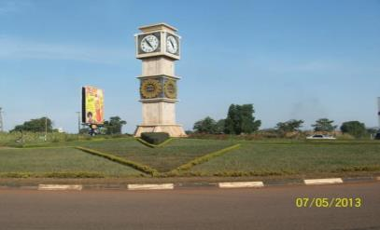

**Some of the beautifull sceneries of Jinja City.**

**Challenges**

In addition to the constraints mentioned above, Jinja city faces the following challenges:

1. High levels of unemployment and under employment especially among the youths, the women and other vulnerable groups.
2. COVID 19 that has greatly affected most of our local revenue centres likie the source of the Nile was one of our major revenue centres.
3. Inadequate parking space for vehicles especially in the CBD which contributes to congestion and traffic jams. Provision of underground parking is now a pre-condition for all new buildings and those being designed.
4. Political pronouncements such as the suspension of taxes on Buses and Taxis have affected capacity for local revenue collection.
5. Solid waste management is a key challenge , we don’t have adequate refuse trucks to compliment the private service providers. Irregular supply of fuel and other logistics makes it difficult to manage garbage in a continuous and consistent manner.
6. Street children that vandalize expensive establishments like solar street batteries is another challenge.
7. Lack of road construction equipment to work on our roads is also worthy noting. We usually borrow form the district which also a heavy work loads.
8. Inadequate technical staff to man the activities of the expanded city is also another challenge.
9. High rate of poverty
10. Illiteracy and lack of ability to understand and interpret policies and laws
11. Weak civil society
12. Challenges with press

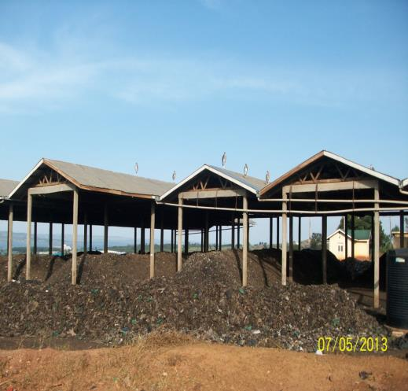

Jinja city land fill. Solid waste management is one of the key challenges the city is facing.

**Future plans**

* Rebranding Jinja
* Redevelopment of source of the Nile
* Improvement of housing from low income to middle income
* Improvement on slum areas
* Invest in renewable energy
* Development of a public transport terminal
* Transport terminal
* Public University
* Construction of a Uganda History museum
* Redevelopment of the Jinja port
* Redevelopment of Kimaka airport
* Development of Sports Grounds/Stadium
* Provision of Infrastructure and Services for an Industrial Park
* Modern Shopping Centre